***Introduction***

***<!DOCTYPE html>***

Declares the document type and HTML version. Here, it specifies HTML5.

***<html lang="en">***

Starts the HTML document and sets the language to English.

***<head> Section***

***<meta charset="UTF-8">***

Specifies the character encoding as UTF-8, which supports most characters and symbols.

***<title>Google Translate </title>***

Sets the title of the webpage that appears in the browser tab.

***<style>***

***#google_translate_element {***

***position: fixed;***

***top: 10px;***

***right: 10px;***

***z-index: 1000;***

***}***

• position: fixed: Keeps the Google Translate dropdown in a fixed position, even when the user scrolls.

• top: 10px; right: 10px;: Places the dropdown in the top-right corner.

• z-index: 1000;: Ensures the element appears above most other page content.

***body {***

***font-family: Arial, sans-serif;***

***margin: 50px;***

***}***

Sets a clean font and spacing for your content.

***<body> Section***

***<div id="google_translate_element"></div>***

This is the placeholder where the Google Translate widget will be inserted by JavaScript.

***<h1>...</h1> and <p>...</p>***

Regular page content to demonstrate translation.

Google Translate Script

JavaScript Initialization

***function googleTranslateElementInit() {***

***new google.translate.TranslateElement(***

***{pageLanguage: 'en'},***

***'google_translate_element'***

***);***

***}***

• Function Name: googleTranslateElementInit — this must match the callback name in the script loader.

• pageLanguage: 'en': Sets the default/original language of the webpage.

• 'google_translate_element': The ID of the <div> where the widget will appear.

Loading the Google Translate API

***<script type="text/javascript"***

***src="https://translate.google.com/translate_a/element.js?cb=googleTranslateElementInit">***

***</script>***

• Loads the Google Translate script.

• The cb parameter (cb=googleTranslateElementInit) tells Google to run the initialization function once the script is loaded.

***Summary***

This code creates a floating Google Translate widget on your webpage that allows users to choose a language to translate your site. It loads the widget from Google’s servers and automatically inserts it into the specified <div>.

***Code of Google Translator***

***<!DOCTYPE html>***

***<html lang="en">***

***<head>***

***<meta charset="UTF-8">***

***<title>Google Translate Example</title>***

***<style>***

***/* Optional styling for the translate element */***

***#google_translate_element {***

***position: fixed;***

***top: 10px;***

***right: 10px;***

***z-index: 1000;***

***}***

***body {***

***font-family: Arial, sans-serif;***

***margin: 50px;***

***}***

***</style>***

***</head>***

***<body>***

***<div id="google_translate_element"></div>***

***<h1>Welcome to My Website</h1>***

***<p>This is a simple example of integrating Google Translate.</p>***

***<!-- Google Translate Script -->***

***<script type="text/javascript">***

***function googleTranslateElementInit() {***

***new google.translate.TranslateElement(***

***{pageLanguage: 'en'},***

***'google_translate_element'***

***);***

***}***

***</script>***

***<script type="text/javascript"***

***src="https://translate.google.com/translate_a/element.js?cb=googleTranslateElementInit">***

***</script>***

***</body>***

***</html>***

***Output of code***

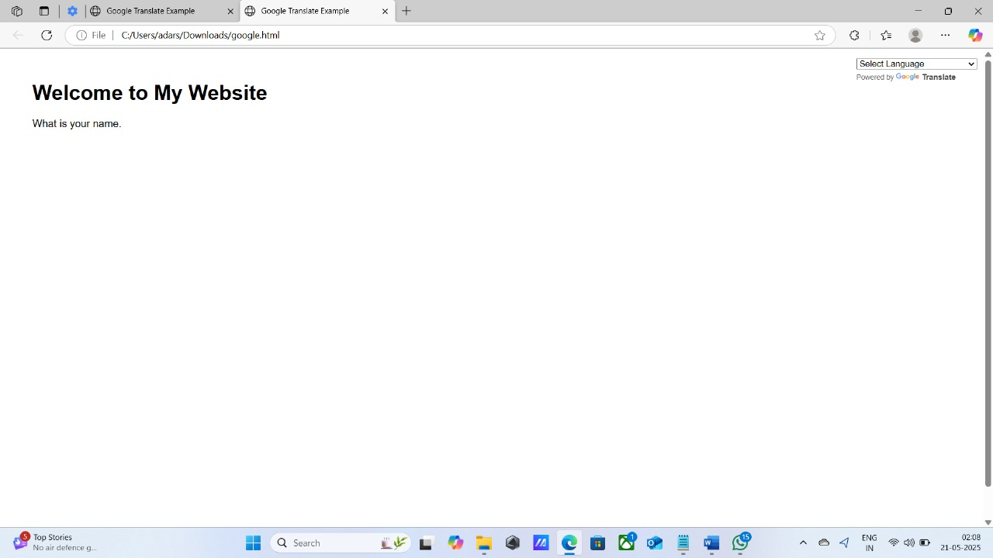

Limitations of This Google Translate Integration

1. Outdated & Unofficial for New Projects

• Google deprecated the Google Website Translator plugin for new users in 2019.

• While the code may still work, Google does not officially support new integrations, and functionality may stop working at any time.

2. Inconsistent Styling

• The widget’s dropdown menu and translated text styling cannot be fully customized.

• The appearance may not match your site’s design and can look out of place.

3. Not SEO-Friendly

• Translated content is done client-side using JavaScript.

• Search engines cannot index the translated pages, meaning you don’t gain SEO benefits from offering multiple languages.

4. Limited Control Over Language Handling

• You can’t easily customize translations, correct errors, or provide custom language pairs.

• There is no way to force translation or remember the selected language across sessions without using cookies and extra logic.

5. Privacy & Legal Compliance

• Since this loads a script from Google, it may track user interactions.

• You may need to update your privacy policy and ensure GDPR compliance if you’re targeting users in the EU or similar jurisdictions.

6. Performance Overhead

• The widget loads a script from an external source (translate.google.com), which can slightly increase load times or create issues if Google services are blocked or slow.

7. Branding Requirement

• You must keep the Google branding and “Powered by Google Translate” notice visible, as per Google’s terms of use.

⸻

Better Alternatives

If you want more professional or controllable solutions, consider:

• Server-side translation and multilingual sites (e.g., using i18n frameworks).

• Third-party services like Weglot, Phrase, or Transifex.

• Google Cloud Translation API: More flexible and accurate, but requires backend integration and billing.

